# DAYANANDA SAGAR UNIVERSITY



Department of Computer Science & Engineering (AIML)

Devarakaggalahalli, Harohalli Kanakapura Road,

Ramanagara - 562112

Karnataka, India

## A Report on

**“Driver Drowsiness Detection”**

**Department of Computer Science Engineering (CSE)**

**SUBMITTED BY**

**KIRTI VARDHAN (ENG22CS0342)**

**PRIYANKA DAS (ENG22CS0397)**

**KEVIN V SHIBU (ENG22CS0081)**

**Under the supervision of**

##### **Dr. RENUKADEVI M N**

**Assistant Professor**

**Dept. of CSE, SOE, DSU**

**2023 - 2024**

**DAYANANDA SAGAR UNIVERSITY**

School of Engineering

Department of Computer Science & Engineering (AIML)

Devarakaggalahalli, Harohalli, Kanakapura Road,

Ramanagara – 562112

Karnataka, India

# Department of Computer Science Engineering (CSE)

# 

**CERTIFICATE**

This is to certify that the Digital Image Processing project work titled **“Driver drowsiness detection”** is carried out by **Kirti Vardhan (ENG22CS0342), Priyanka Das (ENG22CS0397),** **Kevin V Shibu (ENG22CS0081),** bonafide students of Bachelor of Technology in Computer Science and Engineering (CSE) at the School of Engineering, Dayananda Sagar University in partial fulfillment for the award of degree in Bachelor of Technology in Computer Science and Engineering (CSE), during the year **2023-2024**.

----------------------------- ---------------------------------

Signature of Guide Signature of Chairperson

**Dr. RENUKADEVI M N**  **Dr. GIRISHA GS**

**Assistant Professor Professor and Chairperson,**

**Dept. of CSE, SOE, DSU Dept. of CSE, SOE, DSU**

DECLARATION

We, **Kirti Vardhan (ENG22CS0342), Priyanka Das (ENG22CS0397),** **Kevin V Shibu (ENG22CS0081),** are students of the fifth semester B.Tech in **Computer Science and Engineering(CSE)**, at School of Engineering, **Dayananda Sagar University**, hereby declare that the Digital Image Processing project titled **“Driver Drowsiness Detection”** has been carried out by us and submitted in partial fulfillment for the award of degree in **Bachelor of Technology in Computer Science and Engineering(CSE)** during the academic year **2023‑2024**.

**ACKNOWLEDGEMENT**

It is a great pleasure for us to acknowledge the assistance and support of many individuals who have been responsible for the successful completion of this project work.

First, we take this opportunity to express our sincere gratitude to School of Engineering & Technology, Dayananda Sagar University for providing us with a great opportunity to pursue our Bachelor’s degree in this institution.

We would like to thank **Dr. Udaya Kumar Reddy K R.**, Dean, **School of Engineering & Technology**, **Dayananda Sagar University** for his constant encouragement and expert advice. It is a matter of immense pleasure to express our sincere thanks to **Dr. Girisha GS,** **Department Chairperson**, **Computer Science and Engineering (CSE)**, **Dayananda Sagar University,** for providing the right academic guidance that made our task possible.

We would like to thank our guide **Dr. Renukadevi M N**, **Assistant Professor**, **Dept. of Computer Science and Engineering (CSE)**, **Dayananda Sagar University**, for sparing her valuable time to extend help in every step of our Special Topic-1 work, which paved the way for smooth progress and the fruitful culmination of the research.

We are also grateful to our family and friends who provided us with every requirement throughout the course. We would like to thank one and all who directly or indirectly helped us in the Digital Image Processing project work.

**TABLE OF CONTENTS**

Acknowledgement

Abstract

1. Introduction
   1. Introduction
   2. Objectives
   3. Motivation
   4. Overview of the Project
   5. Chapter wise Summary
2. Analysis and Design
   1. Functional Requirements
   2. Architecture
   3. Use case diagram
   4. Sequence Diagram
3. Implementation

3.1 Code Snippets

3.2 Implementation

1. Conclusion and Further Scope
2. References

Abstract

Drowsiness and fatigue are one of the main causes leading to road accidents. They can be prevented by taking effort to get enough sleep before driving, drink coffee or energy drink, or have a rest when the signs of drowsiness occur. The popular drowsiness detection method uses complex methods, such as EEG and ECG. This method has high accuracy for its measurement but it needs to use contact measurement and it has many limitations on driver fatigue and drowsiness monitor [18]. Thus, it is not comfortable to be used in real time driving. This paper proposes a way to detect the drowsiness signs among drivers by measuring the eye closing rate and yawning.

This project describes on how to detect the eyes and mouth in a video recorded from the. In the video, a participant will drive the driving simulation system and a webcam will be place in front of the driving simulator. The video will be recorded using the webcam to see the transition from awake to fatigue and finally, drowsy. The designed system deals with detecting the face area of the image captured from the video. The purpose of using the face area so it can narrow down to detect eyes and mouth within the face area. Once the face is found, the eyes and mouth are found by creating the eye for left and right eye detection and also mouth detection.

The parameters of the eyes and mouth detection are created within the face image. The video was change into images frames per second. From there, locating the eyes and mouth can be performed. Once the eyes are located, measuring the intensity changes in the eye area determine the eyes are open or closed.

If the eyes are found closed for 4 consecutive frames, it is confirmed that the driver is in drowsiness condition

**1.INTRODUCTION**

Drowsiness is a state of near sleep, where the person has a strong desire for sleep. It has two distinct meanings, referring both to the usual state preceding falling asleep and the chronic condition referring to being in that state independent of a daily rhythm [16]. Sleepiness can be dangerous when performing tasks that require constant concentration, such as driving a vehicle. When a person is sufficiently fatigue while driving, they will experience drowsiness and this leads to increase the factor of road accident.

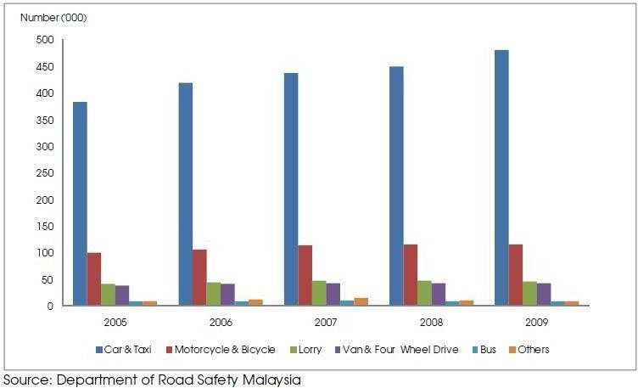

Figure 1: Statistic of Road Accident from 2005 to 2009

Figure 1 shows the statistic of road accident. The numbers of vehicles involved in road accident keep increasing each year. From Figure 1, car and taxi type of vehicles shows about nearly 400,000 cases of road accident has been recorded. It keeps increasing every year and by the year 2009, it shows the number of road accident was recorded by nearly 500,000.

Figure 2 shows the difference between fatigue and drowsiness condition.



Figure 2: Examples of Fatigue & Drowsiness Condition

The development of technologies for detecting or preventing drowsiness while driving is a major challenge in the field of accident-avoidance system. Because of the hazard that drowsiness presents on the road, methods need to be developed for counteracting its affects.

The aim of this project is to develop a simulation of drowsiness detection system. The focus will be placed on designing a system that will accurately monitor the open or closed state of the driver’s eyes and mouth. By monitoring the eyes, it is believed that the symptoms of driver's drowsiness can be detected in sufficiently early stage, to avoid a car accident. Yawning detection is a method to assess the driver’s fatigue. When a person is fatigue, they keep yawning to ensure that there is enough oxygen for the brain consumption before going to drowsiness state. Detection of fatigue and drowsiness involves a sequence of images of a face, and the observation of eyes and mouth open or closed duration. Another method to detect eye closure is PERCLOS. This detection method is based on the time of eyes closed which refers to percentage of a specific time.

The analysis of face images is a popular research area with applications such as face recognition, and human identification and tracking for security systems.

This project is focused on the localization of the eyes and mouth, which involves looking at the entire image of the face, and determining the position of the eyes and mouth, by applying the existing methods in image- processing algorithm. Once the position of the eyes is located, the system is designed to determine whether the eyes and mouth are opened or closed, and detect fatigue and drowsiness.

* 1. **Objectives**

The project focuses on these objectives, which are:

* + - To suggest ways to detect fatigue and drowsiness while driving.
    - Study on eyes and mouth from the video images of participants in the experiment of driving simulation that can be used as an indicator of fatigue and drowsiness.
    - To investigate the physical changes of fatigue and drowsiness.
    - To develop a system that use eyes closure and yawning as a way to detect fatigue and drowsiness.
  1. **Motivation**

Driver drowsiness is a significant factor in the increasing number of accidents on today’s roads and has been extensively accepted. This proof has been verified by many researchers that have demonstrated ties between driver drowsiness and road accidents. Although it is hard to decide the exact number of accidents due to drowsiness, it is much likely to be underestimated. The above statement shows the significance of a research with the objective of reducing the dangers of accidents anticipated to drowsiness. so far, researchers have tried to model the behavior by creating links between drowsiness and certain indications related to the vehicle and to the driver.

Previous approaches to drowsiness detection primarily make pre-assumptions about the relevant behavior, focusing on blink rate, eye closure, and yawning. The automobile business also has tried to build several systems to predict driver drowsiness but there are only a few commercial products available today. The systems do not look at driver performance and overlook driver ability and characteristics. Naturally, most people would agree that different people drive differently. The system that being develop able to adapt to the changes of the driver’s behavior.

* 1. **Overview of the Project**

Drowsiness detection is a safety technology that can prevent accidents that are caused by drivers who fell asleep while driving.

The objective of this intermediate Python project is to build a drowsiness detection system that will detect that a person’s eyes are closed for a few seconds. This system will alert the driver when drowsiness is detected.

* 1. **Chapter wise Summary**

During long journeys, it’s possible that the driver may lose attention because of drowsiness, which may be a potential reason for fatal accidents. With technologies like Driver Drowsiness Detection getting, it is possible to detect driver’s driving behavior that may prove fatal to the vehicle as well as the people boarding it.

Having such sleep detection system in cars embedded in vehicles could protect precious lives and property worth billion dollars. The outcome would be positive – it would be suitable for fleet owners as well as individual vehicle users. In either case, the objective is identical by sleep detection while driving. The driver drowsiness detection system uses Image Processing to analyze the driver’s eye blink pattern by sitting on the vehicle’s dashboard

If the eye lid movements are abnormal than usual then the detection system triggers the alarm thus alerting the driver about the condition.

**2.Analysis and Design**

2.1 Function Requirements

Visual Studio Code is a free coding editor that helps you start coding quickly. Use it to code in any programming language, without switching editors. Visual Studio Code has support for many languages, including Python, Java, C++, JavaScript, and more.

Python:

We have used pythons 3.6 version which support OpenCV and packages for face recognition. Python is an interpreter, general purpose programming language. It is easy to understand.

OpenCV:

It is a library of many programming functions which is mainly used for real time computer vision program.

Win sound:

If eyes are closed for more interval of time with the help of play sound application it will be able to play the alarm.

Threading and Time:

Library for handling threading and time operation.

* 1. 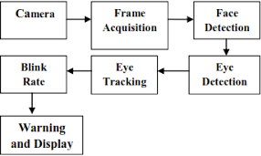 Architecture

2.3 Use case diagram

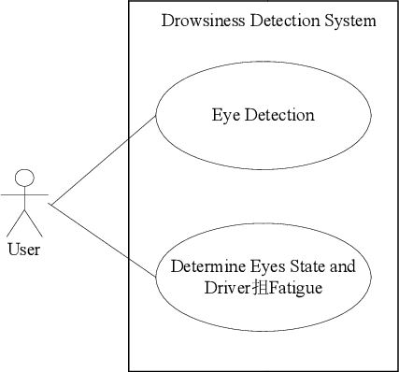

Fig 2: use case diagram

2.4 Sequence Diagram

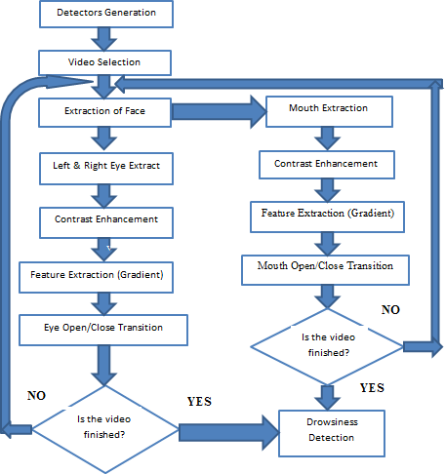

**3.Implementation**

3.1 Code Snippets:

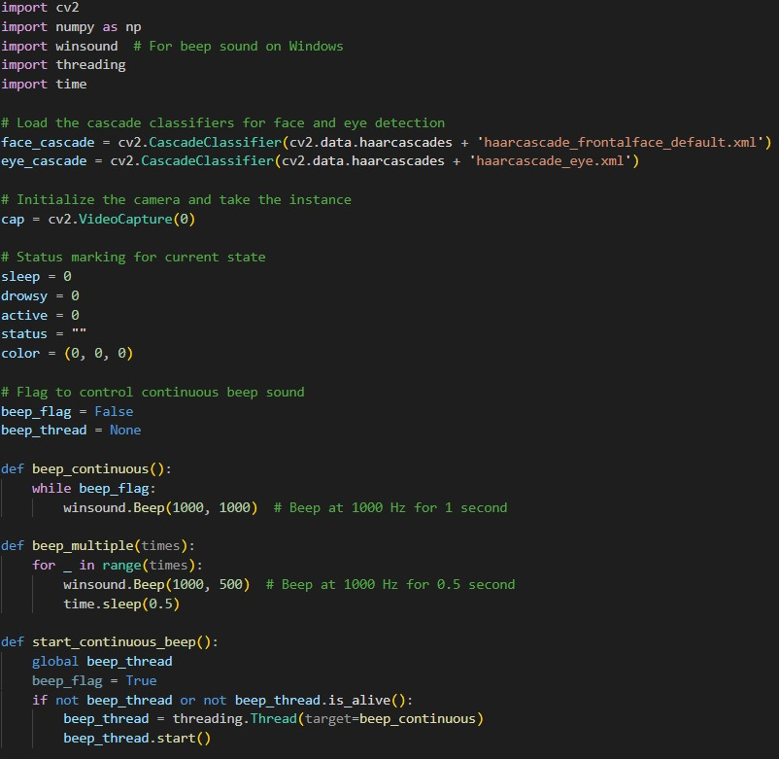

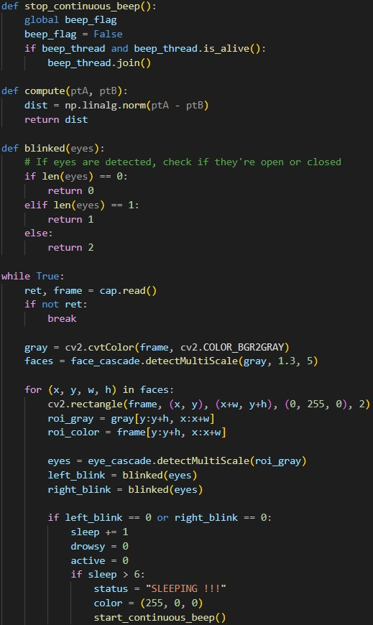

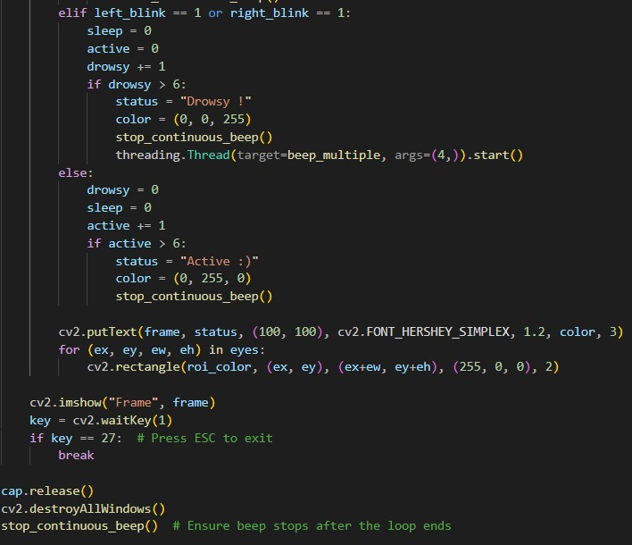

3.2 Implementation

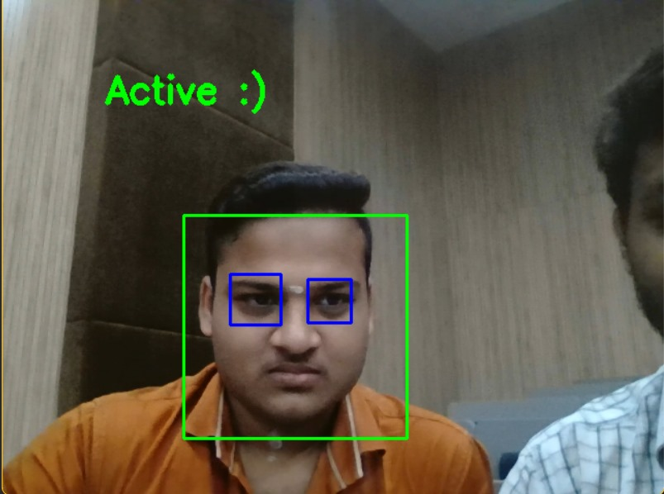

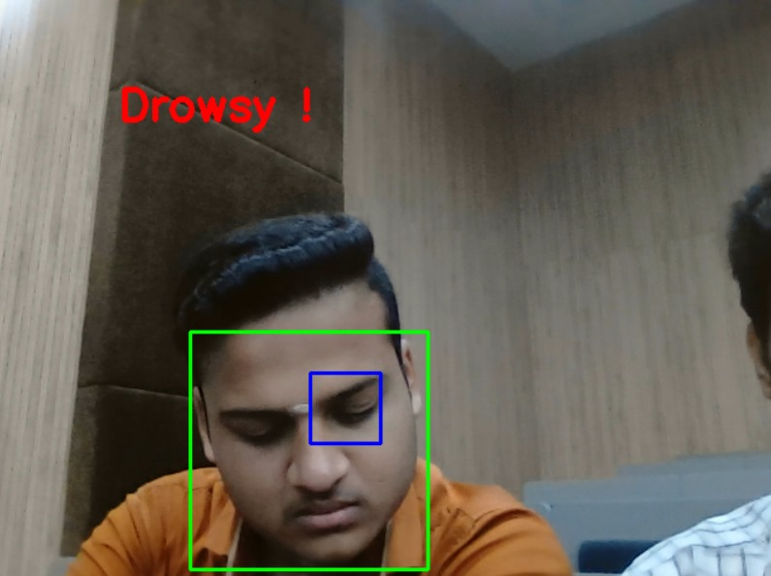

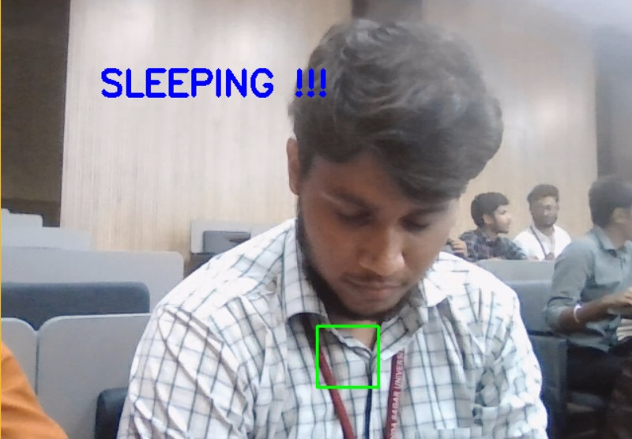

**4. CONCLUSION AND FUTURE WORK**

Thus, we would have successfully designed and developed partial implementation of the Driver Drowsiness Detector using Python and OpenCV along with the cam to detect the face. The system to be developed is to be tested and limitations are identified. The rest of the work will be done according to what is planned already. This framework can be stretched out further to have abundant security highlights, for example, just a certain no of individuals can have specialist get to or work the vehicle. If there should be an occurrence of an endeavor to robbery, the vehicle's motor doesn’t begin or an alarm sound. A picture of the burglar is taken in an attempted theft &sent to the owner of the vehicle who can register a case against the thief of the vehicle.